Telescopic Conveyor |  | 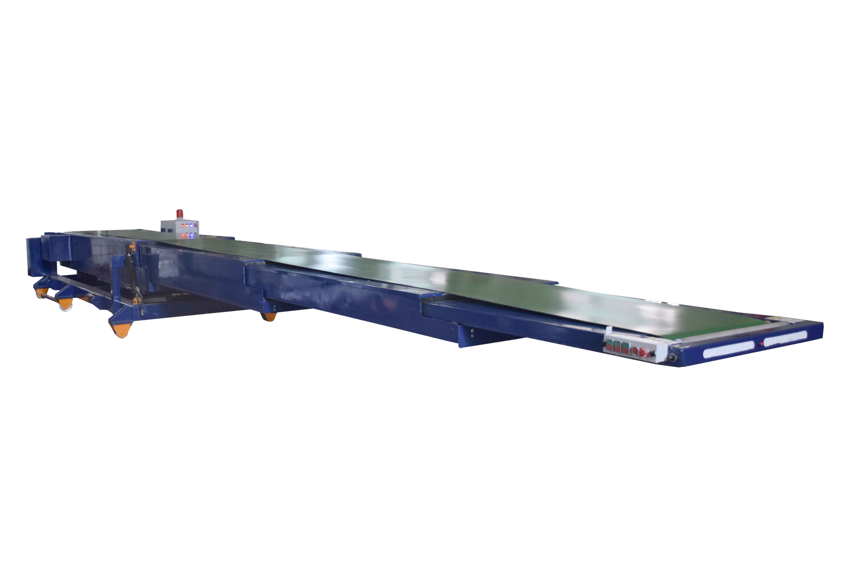
Make | NIHVA
Color | Golden Yellow
Material To Be Handle | Boxes / Bags
Weight Of The Box/Bags | Up to 100 Kgs.
Belt Width in MM | Depends on load dimensions
Type Of Belt | Smooth Top 2 Ply, PVC Coated Endless type,
Main Body Of Conveyor | Manufacturing from 6 MM Thick. IS 226 Plate Material
Snub Pulley For Conveyor | Precision Machine from 3 Inch OD Schedule 40 Pipe With Inverted Bearing Fitted
Drive Pulley | Manufacture from 8 Inch ID Schedule 40 Pipe With Rubber Legging & hearing bone surface
Telescopic Movement | Mechanical arrangement (Diamond make chain)
Mounting | On Fixed MS Chassis Mounted On fabricated frame with FIX and CASTOR wheel with manual toeing bar
Height Adjustment | With 2 HP power pack & cylinder for height adjustment ( Rexroth parts),(ABB motor)
Belt Motor | 3 HP, 1440 RPM, TEFC
Motor - Telescopic Movement | 2 HP, 1440 RPM, TEFC
Motor - Transverse Movement | 1.5 HP
Gear Box | Worm Type, Wall Mounted, With Suitable Ratio
Control Panel | Fixed Main Panel on rear side. Operating Panel with emergency stopper sensor bar, LED lighting on Front side.
Add some point
Size of Box /Bag -600 (L) x 300 (W) x 400 (H) (OVERALL)
Design Capacity- 600 Boxes per hour
Length of Conveyor

